# What you will need to do

You will have to make a new Garuda gadget that will link several other gadgets together. Namely, AGCT’s Garuda gadget, SHOE’s Garuda gadget, Bio-Compendium, Reactome, Percellome. The new gadget will also have to collect information from the TargetMine database. The purpose of the new gadget is to compile the information from many of the other gadgets / databases into one place to be analysed, and optimise the workflow for toxicologist.

AGCT is a clustering tool which can be used to cluster genes. Gene annotation can be given to AGCT which can then be passed on along to its Garuda gadget. Gene annotation is providing information about a specific gene (this might be its function, or how it is affected by a drug). This data can then be sent to AGCT’s Garuda gadget which will be able to send it to the new gadget.

SHOE enables users to explore potential interactions between transcription factors and target genes via multiple data views, discover transcription factor binding motifs on top of gene co-expression. Genes and transcriptional factors are sent from SHOE to SHOE’s Garuda gadget. SHOE’s Garuda gadget will then send the data to either the new gadget or to Cell Designer.

Cell designer allows the user to analyse a specific gene networks and pathways. The genes from a specific network or pathway can be selected so only those genes will be passed to the new gadget to be analysed.

Bio-Compendium, Reactome, Percellome and TargetMine are databases for gene annotation. So, if you request information about a specific gene (or many), they will provide the information that they have of it. Bio-Compendium, Reactome, Percellome can be queried through the Garuda SDK. TargetMine will have to be queried via the InterMine library.

# Tools Needed

You can download all you will need here.

<https://drive.google.com/drive/folders/1bEjjVEUhuAyyOcCbabTvN5fi4PJigv0T?usp=sharing>

## Tools

### Garuda

Garuda is the application that houses many different gadgets for biological analysis. This includes the AGCT gadget, SHOE gadget, Bio-compendium, Cell Designer, Reactome, and Percellome.

Download: [http://www.Garuda-alliance.org/](http://www.garuda-alliance.org/)

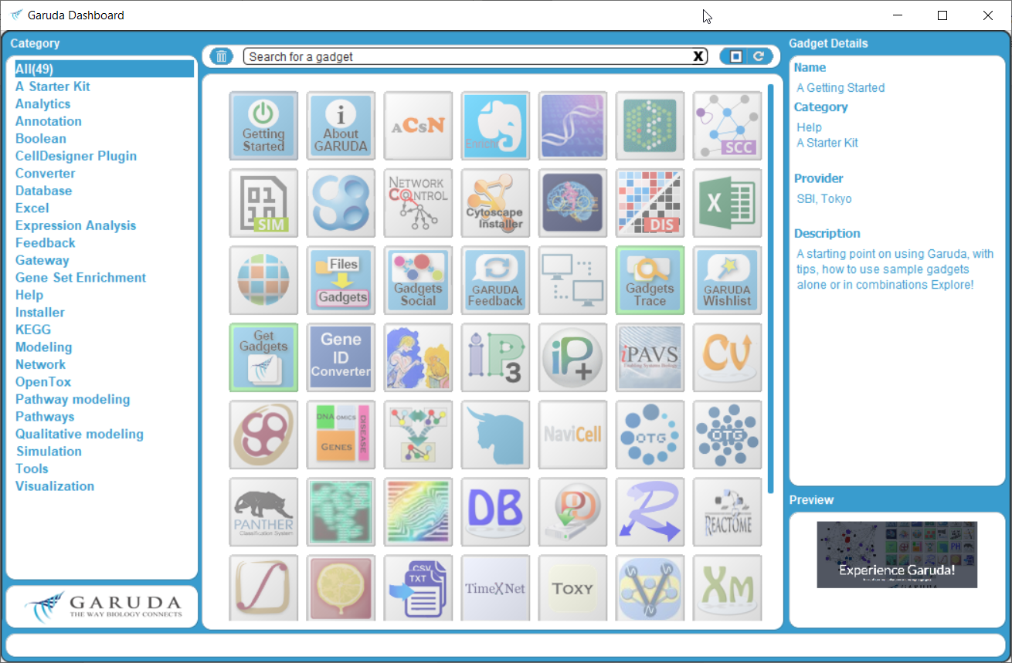

|  |  |  |
| --- | --- | --- |
| Bio-compendium | Reactome | Percellome |
| SHOE | Cell Designer | AGCT …. |

### AGCT (ver 2)

Github: <https://github.com/agct2019/agct/tree/master/Version_2>

JDK 1.8: <https://www.oracle.com/technetwork/java/javase/downloads/jdk8-downloads-2133151.html>

Pre-compiled JAR file: <https://github.com/agct2019/agct/releases/download/v2.0/AGCT2alpha.jar>

Research Paper: <https://github.com/agct2019/agct/blob/master/AGCT_paper_supplementary_information/agct-supplementary-information.pdf>

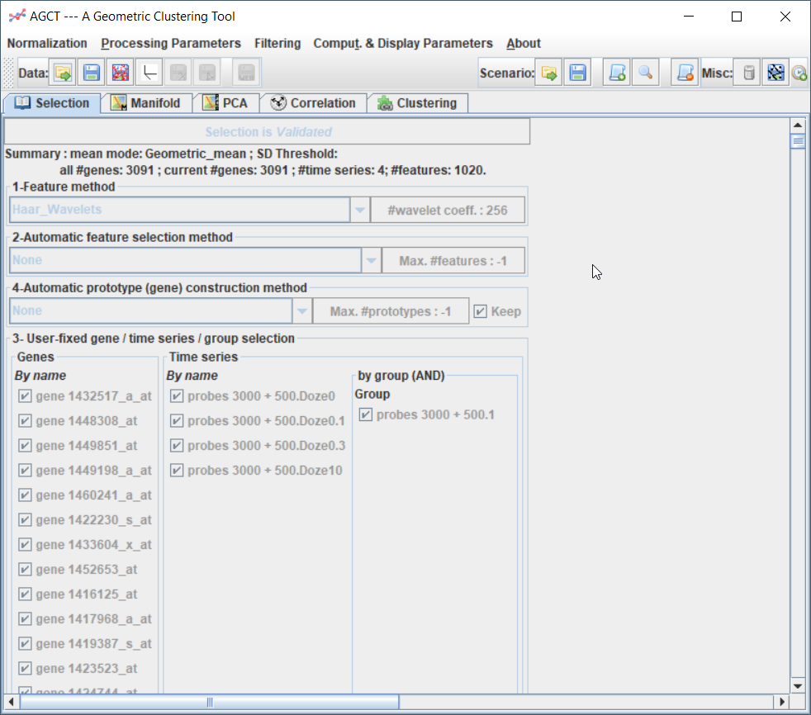

### SHOE

Website: <http://ec2-54-150-223-65.ap-northeast-1.compute.amazonaws.com/>

Research Paper: <https://bmcgenomics.biomedcentral.com/articles/10.1186/s12864-018-5101-3>

Video Demonstration: [https:/www.youtube.com/watch?v=qARinNb9NtE](https://www.youtube.com/watch?v=qARinNb9NtE)

## Development Tools

### Garuda SDK

Garuda SDK is the standard development kit for Garuda gadgets. It is what will be used to communicate between the different gadgets.

Development Pack – Under “Garudify Your Tools”:

[http://www.Garuda-alliance.org/](http://www.garuda-alliance.org/)

Documentation – Included in the development pack as a Java Doc:

“C:/.../GarudaDevPack/GarudaSDKs/Java/GarudaJavaSDK2.0Guide.html”

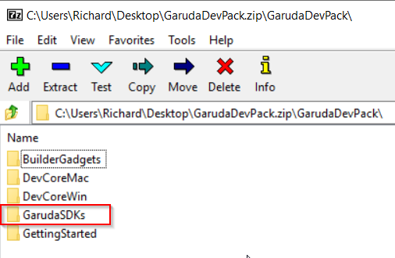

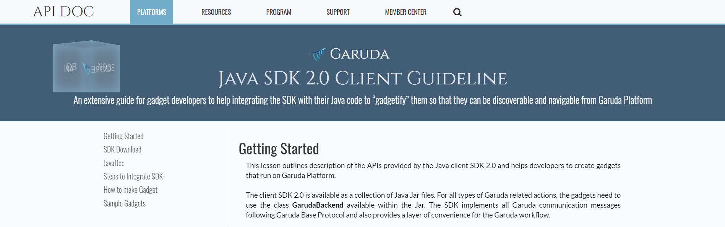

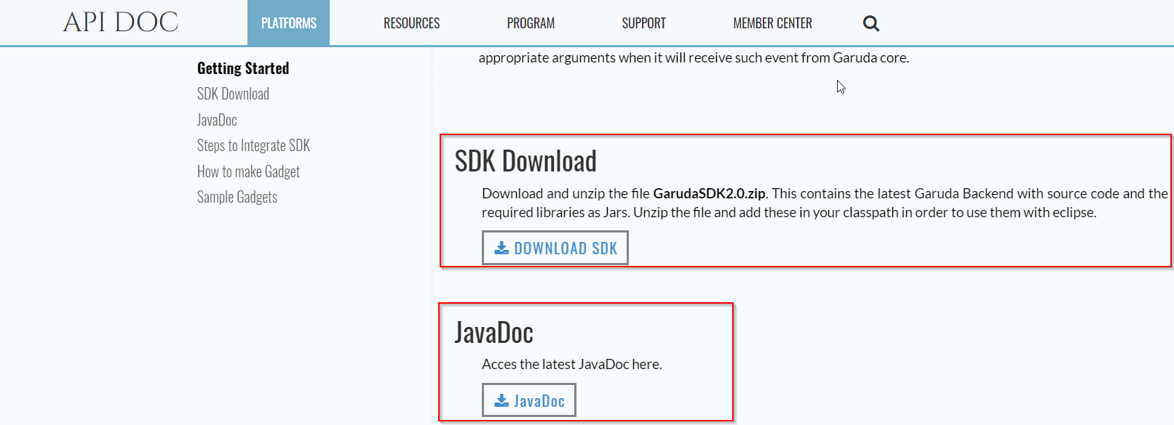

### Eclipse (for Java)

Eclipse is the IDE that I would recommend for developing the Java application.

Download: <https://www.eclipse.org/ide/>

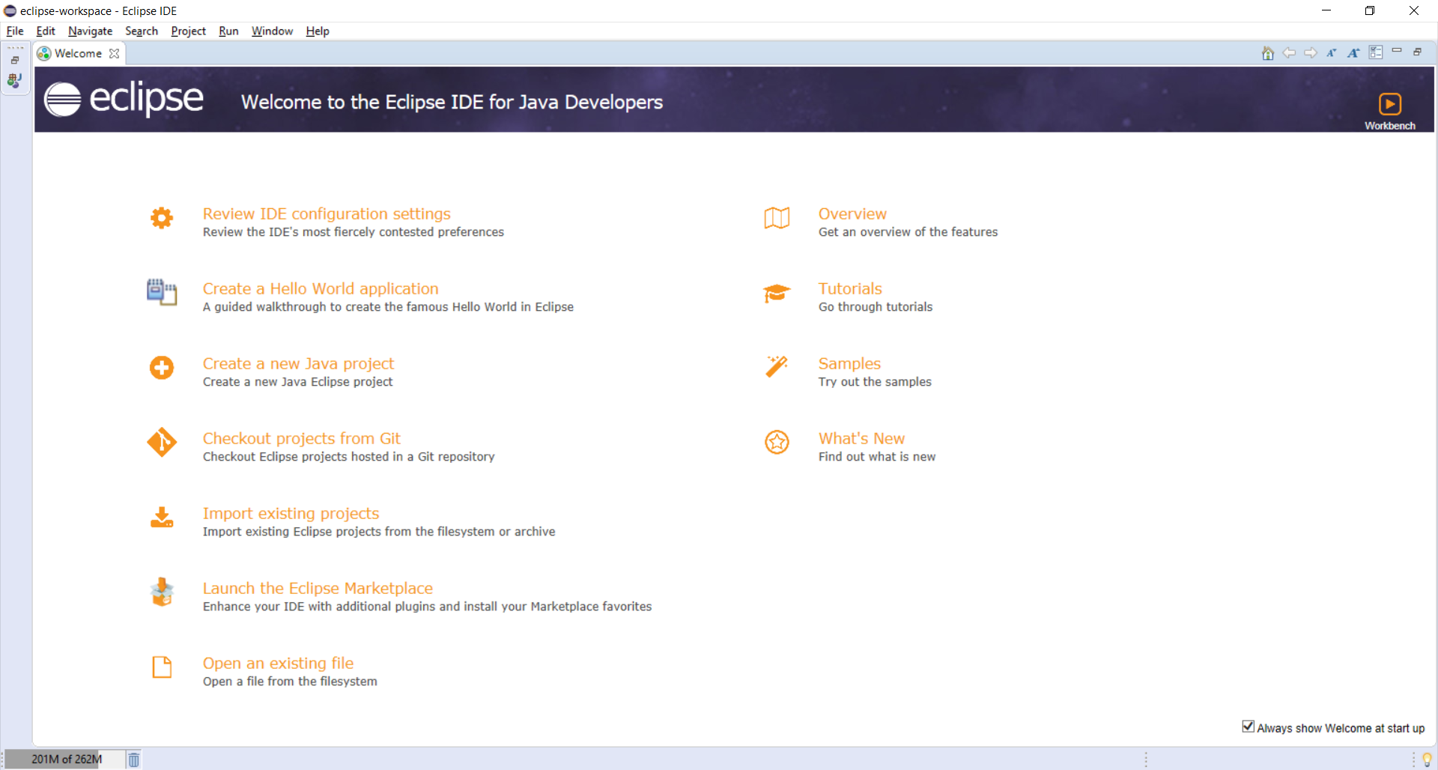

### Java Swing

Java Swing is a library that will let you design and implement the GUI for the new gadget.

Documentation: <https://docs.oracle.com/javase/7/docs/api/javax/swing/package-summary.html>

Eclipse plugin for Java Swing: <https://marketplace.eclipse.org/content/windowbuilder>

### InterMine API

TargetMine is based off the InterMine framework. To query the TargetMine database for information about a gene you can use InterMine library.

InterMine Website (example code): [http://InterMine.org/#](http://intermine.org/)

InterMine Doc: [http://InterMine.org/InterMine-ws-java/javadoc/](http://intermine.org/intermine-ws-java/javadoc/)

Github: [https://github.com/InterMine/InterMine](https://github.com/intermine/intermine)

TargetMine Website: <https://targetmine.mizuguchilab.org/>

# How will you do it

## Dataflow Diagram

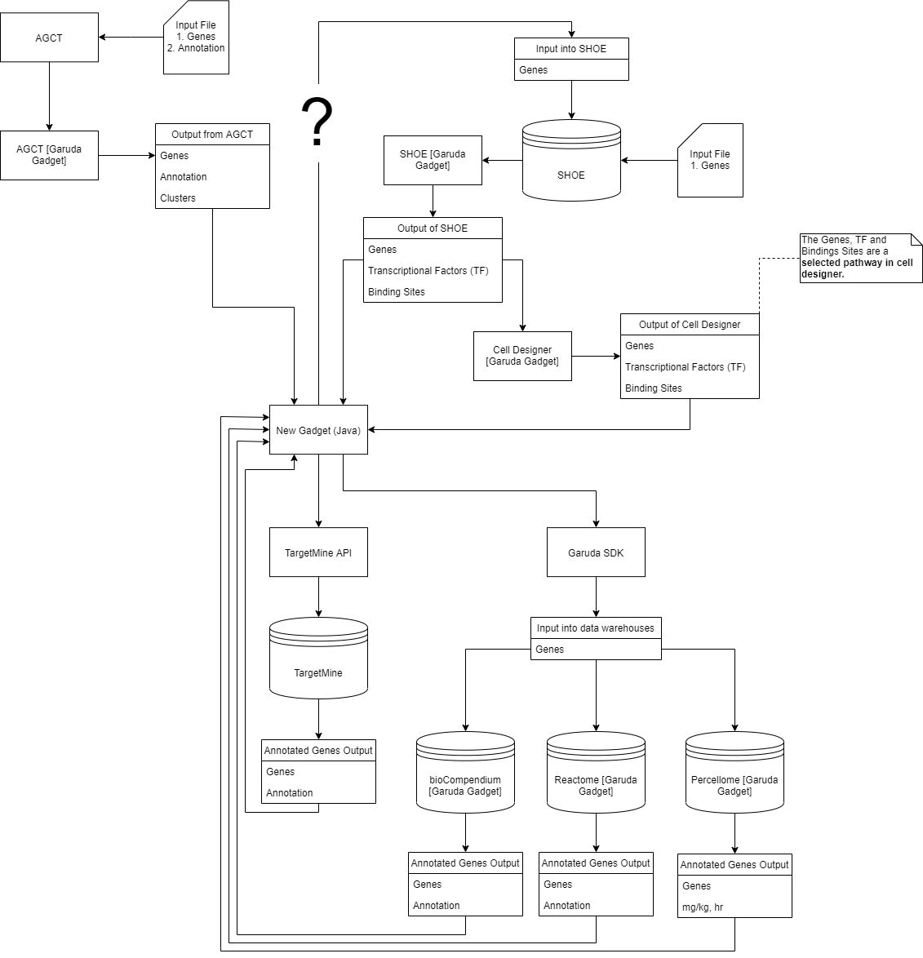

## Gadget Inputs

|  |  |
| --- | --- |
| **Biocompendium** | |
| Input | |
| TXT | Ensemble |
| CSV | CSV |
| CSV | Ensemble |
| Output | |
| TXT | Genelist |
| TXT | TXT |
| TXT | KEGG |
| CSV | Ensemble |
| <http://garuda-alliance.org/GarudaCommunity/gadgets-main.jsp?page=details&gadget_id=1313> | |

|  |  |
| --- | --- |
| **Cell Designer** | |
| Input | |
| XML | SBML |
| XML | Cell Designer |
| Output | |
| XML | SBML |
| XML | Cell Designer |
| <http://garuda-alliance.org/GarudaCommunity/gadgets-main.jsp?page=details&gadget_id=1363> | |

|  |  |
| --- | --- |
| **Percellome** | |
| Input |  |
| TXT | Gene List |
| TXT | Protine List |
| Output |  |
| TSV | TSV |
| <http://garuda-alliance.org/GarudaCommunity/gadgets-main.jsp?page=details&gadget_id=1298> | |

|  |  |
| --- | --- |
| **Reactome** | |
| Input | |
| TXT | Gene List |
| TXT | Protein List |
| Output |  |
| CSV | Gene List |
| CSV | Protein List |
| <http://garuda-alliance.org/GarudaCommunity/gadgets-main.jsp?page=details&gadget_id=1354> | |

## Proposed Software Architecture v0.1

This was based off the provided AlgoBuilder2.0 example code provided by Garuda SDK.

